|  |  |  |  |
| --- | --- | --- | --- |
| Name:  Teacher: | ____________________________________  ________________ | | Date: _________ |
|  | **Year 11 Mathematics Essentials**  SCORE: / 45    **Test 5 – Speed, Distance and Time**  ***Full working out MUST be shown to get full marks for each question.*** | | |
| **Total Time:** | 50 minutes |  | |
| **Weighting:** | 10 % |
| **Equipment:** | To be provided by the student: Pens and Pencils, ruler scientific calculator, A4 page of notes. | | |

**Question 1**

Convert the following times below into different units. [6 marks]

1. ¼ century = _______years
2. 669 days = ________ months
3. 90 days = _________ years
4. 3.5 years = ________weeks
5. 367,200 seconds = _________days
6. 12,340 minutes = _________ weeks

**Question 2**

Complete the following table. [5 marks]

|  |  |
| --- | --- |
| **24 hour time** | **12 hour time** |
| 0043 |  |
|  | 3:56 pm |
| 0834 |  |
| 2256 |  |
|  | 12:23pm |

**Question 3** [2 marks]

Marcus is looking forward to his favourite tv show which starts at 5:30pm. It is currently 2:55pm. How long does he need to wait?

**Question 4** [1, 1, 1 =3 marks]

Use the diagram below to answer the following questions

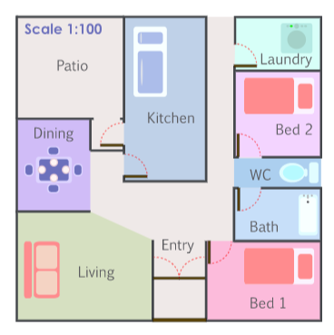

1. According to the scale on the diagram. 1 cm represents how many metres in the house?
2. Using a ruler Jill measured the length of Bedroom 1 on the plan and finds it to be 4 cm. How many metres is this?
3. Jill measured the width of Bedroom 1 and finds it to be 85mm. How many metres is this?

**Question 5**  [3, 2 = 5 marks]

Spud Shed normally sells a large (10 kg) bag of Potatoes for $12, or a medium (4 kg) bag costs $5. Loose potatoes (pick as many as you want) cost $1.80 / kg.

1. Put the three options in order from best value for money to worst value (show your working)
2. If you are cooking a meal that requires 3 kg of potatoes which option would cost the least?

**Question 6 [2, 3 = 5 marks]**

The scale is 1: 1000. Calculate the real life-lengths of each feature on the map:

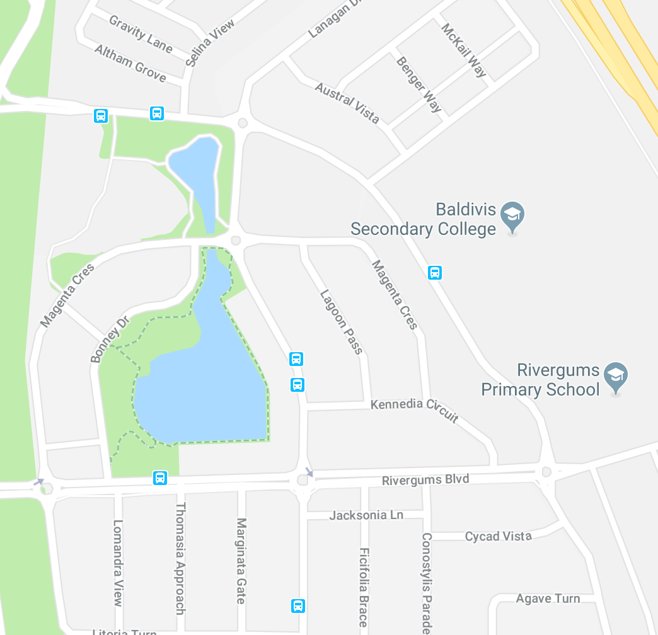

1. The width of the lake in metres (the black dots)
2. If Tommy walks at a speed of 5m per minute, how long does it take him to walk to school?

**Question 7** [3 marks]

A Peregrine Falcon’s top speed is 90m/s.

1. Which of the variables D, S or T has a value of 90?
2. How far can a Peregrine Falcon travel in 6 seconds?
3. If a falcon flew at its top speed, how long would it take to travel 1km to the nearest second?

**Question 8** [3 marks]

Bradley is picking his 3 friends Steve, Marsha and Beryl to go to a restaurant. It will take 11 minutes to get from Bradley’s house to Steve’s, 7 minutes to get from Steve’s house to Marsha’s, 6 minutes to get from Marsha’s to Beryl’s and then 4 minutes to get from Beryl’s house to the restaurant. What time does Bradley need to leave home if the restaurant booking is for 7:30pm?

**Question 9** [2,2,2,2 = 8 marks]

The table below shows the tide heights at a beach for the first two weeks of September.

|  |  |  |  |  |  |  |  |  |
| --- | --- | --- | --- | --- | --- | --- | --- | --- |
| **Date** | **High Tides** | | | | **Low Tides** | | | |
| **Time** | **Height (m)** | **Time** | **Height (m)** | **Time** | **Height (m)** | **Time** | **Height (m)** |
| 1 | 0123 | 2.6 | 1333 | 2.7 | 0738 | 0.5 | 1954 | 0.4 |
| 2 | 0201 | 2.5 | 1411 | 2.6 | 0804 | 0.6 | 2036 | 0.4 |
| 3 | 0241 | 2.4 | 1450 | 2.6 | 0845 | 0.6 | 2122 | 0.5 |
| 4 | 0329 | 2.2 | 1542 | 2.5 | 0931 | 0.7 | 2209 | 0.5 |
| 5 | 0421 | 2.1 | 1634 | 2.5 | 1026 | 0.8 | 2310 | 0.6 |
| 6 | 0520 | 2.1 | 1737 | 2.5 | 1127 | 0.7 | - | - |
| 7 | 0627 | 2.1 | 1845 | 2.6 | 1212 | 0.4 | 1231 | 0.8 |
| 8 | 0734 | 2.3 | 1952 | 2.6 | 0123 | 0.3 | 1340 | 0.7 |
| 9 | 0837 | 2.4 | 2056 | 2.7 | 0224 | 0.2 | 1445 | 0.5 |
| 10 | 0935 | 2.5 | 2157 | 2.8 | 0322 | 0.2 | 1548 | 0.3 |
| 11 | 1027 | 2.7 | 2252 | 2.8 | 0420 | 0.1 | 1645 | 0.2 |
| 12 | 1120 | 2.8 | 2348 | 2.9 | 0510 | 0.1 | 1738 | 0.1 |
| 13 | - | - | 1210 | 2.8 | 0557 | 0.2 | 1827 | 0.1 |
| 14 | 0041 | 2.7 | 1258 | 2.8 | 0643 | 0.2 | 1915 | 0.2 |

1. At what times did the high tides occur on the 4th?
2. What day and time did the high tide of the greatest height occur?
3. What is the time difference between the high and low tides on the morning of the 6th?
4. To go to a secret fishing spot Jack needs to complete a river crossing. To cross the river safely, Jack requires the low tide to be 0.3m or lower. If he doesn’t want to be stranded overnight, what dates can he go fishing in his secret spot?

**Question 10** [5 marks]

Jade travels from her home to Fremantle to go to work. The graph shows the distance Jade was from Fremantle as she travelled to work on Friday. Jade left home at 9:00 am to drive to Fremantle. She stopped at a café for a quick breakfast with her friend Aden. After breakfast, Jade dropped Aden back at his house before she continued her journey to work.



1. What was Jade’s average speed on the way to the café in km/h?
2. How long did Jade and Aden take to have breakfast?
3. At what time did they leave the café?
4. How far does Aden live from the café?
5. After dropping off Aden, what was Jade’s average speed on the way to Fremantle in km/h?